**AWS ELB & ASG???**

|  |  |
| --- | --- |
| **OSI (Open System Interconnection) layers of communication** | **Responsibility of 7 layers** |
|  | **1.Physical layer:**  Physical transmission of data through cables, wires, or wireless signals.  **2.Data link layer:**  Accurate and reliable transmission of data (error correction bits).  .  **3. Network layer:**  Routing data from one device to another on a network (**Route Table** is used).  **4. Transport layer:**  Reliable connection and transport of data in correct order.  **5. Session layer:**  Managing the communication Opening and closing connections between the devices.  **6. Presentation layer:**  Data formatting, compression, and encryption – data understood by the application layer.  **7.Application Layer:**  It provides network services to applications where user can access the resources. |

Note:

|  |  |  |  |
| --- | --- | --- | --- |
| **Protocol** | **Description** | **Connection type** | **Use cases** |
| **HTTP** | Hypertext Transfer Protocol | connectionless | Used to transfer hypertext documents, such as web pages, between a client (web browser) and a server. |
| **HTTPS** | Hypertext Transfer Protocol Secure | connection | A secure version of HTTP that uses Transport Layer Security (TLS) to encrypt data sent between a client and a server. |
| **TCP** | Transmission Control Protocol | connection | A reliable, connection-oriented protocol that guarantees the delivery of data. |
| **UDP** | User Datagram Protocol | connectionless | A connectionless, unreliable protocol that is not guaranteed to deliver data. |

1. **Types of ELB??**

**1. Application Load Balancer (ALB):** (**Path based)**

* ALB is a layer 7 load balancer
* Good choice:
  + Traffics based on url paths, host name, (eg: path based traffic to containers, microservices)
  + Content based requests (inspects the inside content),

**2. Network Load Balancer (ALB):** (**Port based)**

* NLB is a Layer 4 load balancer
* TCP based traffic on the destination port
* provides ultra-low latency and high throughput

(*throughput- how many units of information a system can process in a given amount of time)

* NLB is capable of handling millions of requests per second while maintaining high availability

**3.Classic load balancer (ALB): (Port based)**

* CLB is a Layer 4 load balancer
* Distributing traffic based on network information like IP addresses and ports.
* TCP or SSL protocol

|  |  |  |  |
| --- | --- | --- | --- |
| **Load Balancer** | **ALB** | **NLB** | **CLB** |
| **Throughput** | High | Very High | Moderate to High |
| **Latency** | Low to Moderate | Very Low | Moderate |
| **Supported Protocols** | HTTP, HTTPS | TCP, UDP | TCP, SSL |
| **performance** | Very good performance, especially for HTTP and HTTPS traffic, with advanced routing capabilities. | Excellent performance, ultra-low latency, and high scalability for TCP and UDP-based protocols. | Good performance, but less scalable compared to ALB and NLB. |

1. **CLB Vs ALB?**

|  |  |  |
| --- | --- | --- |
|  | **CLB (Port based)** | **ALB (Path based)** |
| 1 | Operates at Layer 4 of the OSI model | Operates at Layer 7 of the OSI model |
| 2 | It operates at the transport layer (TCP/SSL) | Operates at the application layer (HTTP/HTTPS) of the OSI model (Traffic based on the content of the HTTP/HTTPS requests) |
| 3 | **Basic load balancing features,**  1. Traffic across multiple EC2 instances in different availability zones to improve availability and fault tolerance. | **Advanced Load Balancing Features**   * Path-based routing, * Host-based routing, * Content-based routing, * Support for **websockets** (chat apps) * integrates with AWS Lambda - provides advanced routing and load balancing capabilities for modern applications |
| **CLB** is the older load balancer in AWS and primarily focuses on distributing traffic at the transport layer. **ALB** is a more feature-rich load balancer designed for more granular routing and load balancing decisions (**modern application architectures**) | | |

1. **ALB Vs NLB?**

|  |  |  |
| --- | --- | --- |
|  | **ALB (path based)** | **NLB (Port based)** |
| 1 | layer 7 load balancer | Layer 4 load balancer |
| 2 | operates at the application layer (HTTP/HTTPS) of the OSI model | operates at the transport layer (TCP/UDP) of the OSI model |
| 3 | ALB is designed for modern application architectures | NLB is designed to handle high volumes of traffic and provides ultra-low latency and high throughput |
| 4 | **Uniqueness:** Suitable for applications with complex routing requirements (Traffic based on the content of the HTTP/HTTPS requests) | **Uniqueness:** Handle millions of requests per second (high-performance load balancing) |
| 5. | ALB supports features such as path-based routing, host-based routing, content-based routing, and integration with AWS services like AWS Lambda. | NLB supports static IP addresses for maintaining a consistent endpoint (provides integration with Elastic IP addresses) |
| NLB is ideal for scenarios that require high throughput and low latency, ALB is suitable for modern applications that require flexible routing and advanced features | | |

1. **What is GLB (Gateway Load Balancer)?**

* **GLB is needed:** To set up and run a group of network virtual appliances (NVAs) from third parties that support GENEVE. You can improve security, compliance, and policy rules with the help of these appliances.
* It aims for high performance and high availability.
* Gateway Load Balancer is a cloud service that enables the deployment and management of network virtual appliances (NVAs). It works at the network layer (3rd layer) of the OSI model, monitoring all IP packets across all ports. It routes traffic to the appropriate target group based on the listener rule.

|  |  |  |
| --- | --- | --- |
| **s.no.** | **Network Virtual Appliance (NVAs)** | **Functions** |
|  | Firewall Appliances | Advanced network security, traffic inspection, threat prevention |
|  | Intrusion Detection and Prevention Systems (IDPS) | Monitoring network traffic, detecting and preventing intrusions, malicious activity prevention |
|  | Web Application Firewalls (WAF) | Protecting web applications, mitigating common vulnerabilities, filtering and blocking malicious traffic |
|  | Load Balancers | Traffic distribution across backend servers, scalability and high availability |
|  | VPN Appliances | Secure remote access connections, site-to-site VPN connections |
|  | Network Monitoring Appliances | Network performance monitoring, traffic analysis, troubleshooting network issues |
|  | DDoS Protection System | Detecting and mitigating Distributed Denial of Service (DDoS) attacks, protecting network resources and availability |

1. **What is Stickiness in LB?**

Session stickiness, also known as session affinity, is a feature in load balancers that ensures that when you visit a website or use an application, your requests are consistently routed to the same backend server throughout your session. This is important because it allows the server to remember information specific to you, like your login credentials or the items in your shopping cart.

When session stickiness enabled, the load balancer can identify you as a unique client and direct your requests to the same server each time. This helps maintain your personalized data and context.

**Some use-cases:**

**E-commerce websites:** Maintaining consistent shopping carts throughout the user's session.

**Authentication and authorization:** Preserving user authentication state across multiple requests.

**Stateful applications:** Ensuring uninterrupted collaboration and real-time updates in applications.

**Gaming platforms:** Keeping players connected to the same game server for synchronized gameplay.

**Personalization and user preferences:** Retaining user-specific settings and preferences during a session.

**Streaming services:** Preserving playback state and preferences in video or audio streaming platforms.

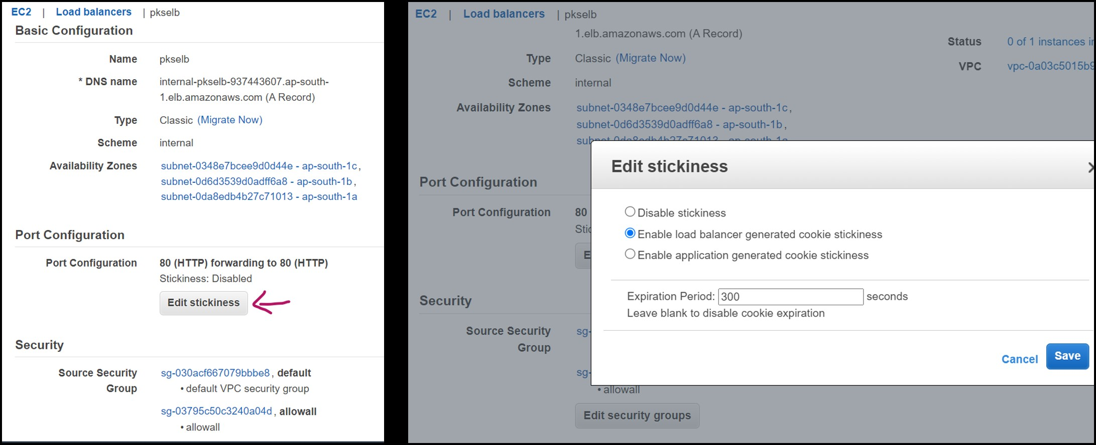

1. **Differentiate between Launch configuration & Launch template in AWS**?

|  |  |  |
| --- | --- | --- |
| **Feature** | **Launch Configuration** | **Launch Template** |
| **Definition** | A launch configuration is a JSON or YAML file that defines the configuration of an EC2 instance. | A launch template is a JSON or YAML file that defines the configuration of an EC2 instance. It also supports **versioning.** |
| **Use** | Launch configurations are used to create Auto Scaling groups. | Launch templates can be used to create Auto Scaling groups, launch EC2 instances directly, or be used as a reference in other AWS services. |
| **Versioning** | Launch configurations **cannot** be versioned. | Launch templates **support** versioning, which allows you to track changes to the template over time. |
| **Recommendation** | AWS recommends using launch templates instead of launch configurations. | AWS recommends using launch templates instead of launch configurations. |
| **Support for new features** | Launch configurations do not support all new features that are released for EC2. | Launch templates support all new features that are released for EC2.  (refer next table for more details:) |

|  |  |  |
| --- | --- | --- |
| **Feature** | **Launch Configuration** | **Launch Template** |
| **EC2 instance types** | Supports only instance types that were released before December 31, 2022. | Supports all instance types, including those that are released in the future. |
| **Purchase options** | Supports only On-Demand Instances. | Supports both On-Demand Instances and Spot Instances. |
| **Dedicated Hosts** | Does not support Dedicated Hosts. | Supports Dedicated Hosts. |
| **EBS encryption** | Supports only EBS encryption with default keys. | Supports EBS encryption with default keys and customer-managed keys. |
| **IAM roles** | Supports only IAM roles that were created before December 31, 2022. | Supports all IAM roles, including those that are created in the future. |
| **Other features** | May not support other new features that are released for EC2. | Supports all new features that are released for EC2. |

1. **What is Grouping Size & Target Scaling?**

Grouping size refers to the number of instances that are in an Auto Scaling group. The desired capacity is the initial size of the group, and you can adjust it up or down as needed. The minimum capacity and maximum capacity are the limits on how small or large the group can be.

Target scaling refers to the way that Auto Scaling adjusts the size of the group based on a metric. There are two types of target scaling: **step scaling and target tracking scaling.**

* **Step scaling** adjusts the size of the group in steps. For example, you could configure Auto Scaling to add one instance when the CPU utilization reaches 80%, and then add another instance when the CPU utilization reaches 90%.
* **Target tracking scaling** adjusts the size of the group to maintain a target value for a metric. For example, you could configure Auto Scaling to maintain a target CPU utilization of 50%. If the CPU utilization goes above 50%, Auto Scaling will add instances. If the CPU utilization drops below 50%, Auto Scaling will remove instances.

1. **How to configure ASG at 9AM MONDAY ?.**

Time I chose is 2.07.2023 8.10 pm

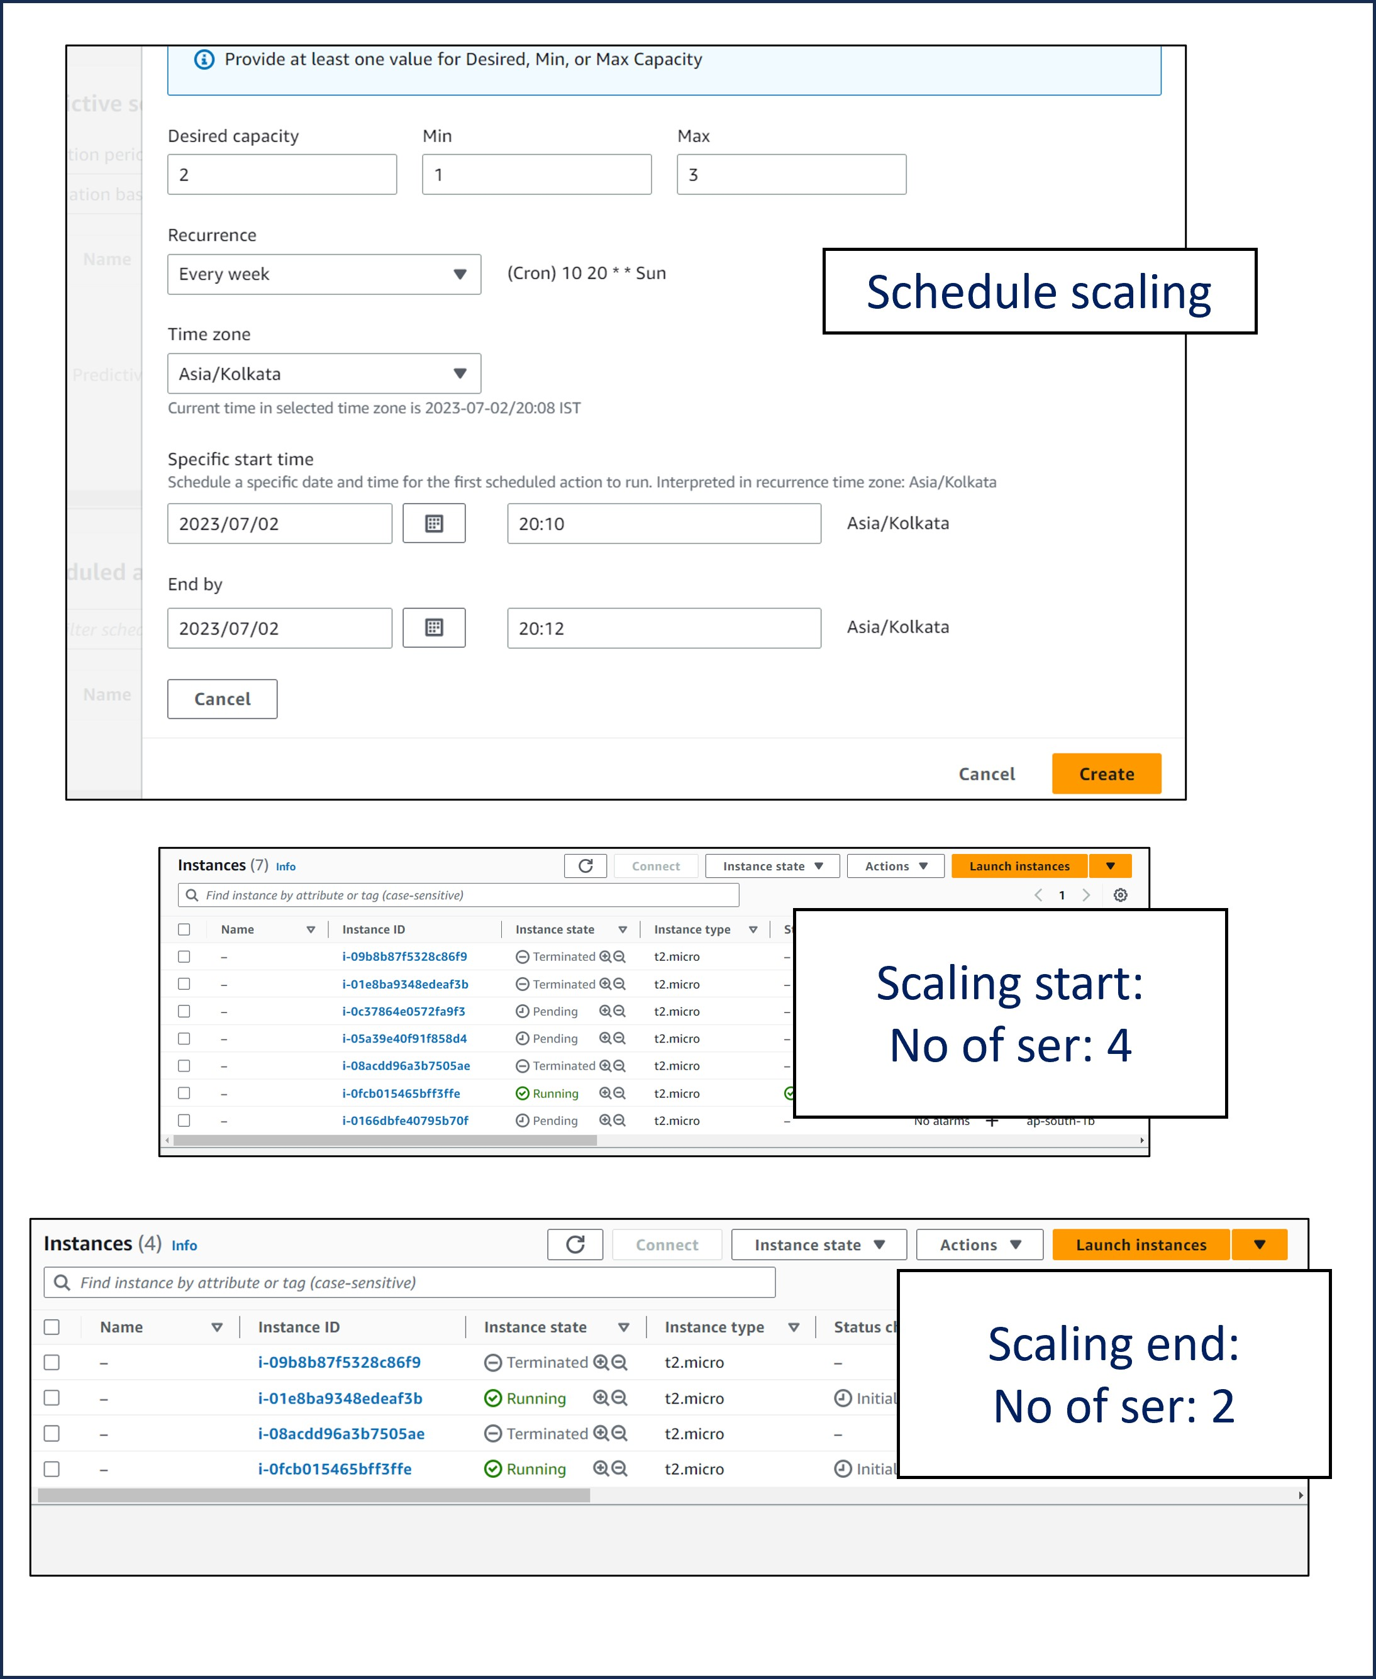

1. **What is Scale-in & Scale-Out?**

|  |  |  |
| --- | --- | --- |
|  | **Scale In** | **Scale Out** |
| **Definition** | Reducing the size or capacity of a system | Increasing the size or capacity of a system |
| **Purpose** | Optimize costs, improve efficiency | Accommodate growth, handle increased workloads |
| **Resource Change** | Remove resources (servers, storage, network) | Add resources (servers, storage, network) |
| **Goal** | Reduce infrastructure and operational costs | Improve system performance and handle increased demand |
| **Main Focus** | Cost reduction and efficiency | Scalability and performance improvement |
| **Suitability** | Decreased user traffic, lower workload, cost optimization | Increased user traffic, higher workload, handle growth |
| **Potential Benefits** | Cost savings, simplified management | Better scalability, improved performance, increased capacity |
| **Potential Challenges** | Limited system capacity | Increased complexity, higher costs, management challenges |

**10. Differentiate Horizontal scaling and Vertical scaling?**

|  |  |
| --- | --- |
| **Horizontal scaling** | **Vertical scaling** |
| Adds more machines or nodes to a system. | Adds more power (CPU, RAM, storage, etc.) to an existing machine. |
| Also known as "scaling out". | Also known as "scaling up". |
| Ideal for handling increasing amounts of traffic or workload. | Ideal for **handling resource-intensive tasks or applications that require more** processing power. |
| **More scalable**, as there is no upper limit to the number of machines that can be added. | **Less scalable**, as there is an upper limit to the amount of power that can be added to a single machine. |
| Easier to implement and manage. | More difficult to implement and manage, as changes need to be made to the underlying software. |
| Typically less expensive, as it does not require the purchase of new hardware. | Typically more expensive, as it requires the purchase of new hardware. |

**11.Is it possible to achieve vertical scaling in AWS?**

Vertical scaling in AWS involves increasing or decreasing the resources of a single instance, and it can be done using services like Amazon EC2 and Amazon RDS. In EC2, you can modify the instance type to scale up or down, while in RDS, you can adjust the instance class to allocate more or fewer resources.

**12. How will you monitor your ELB?**

**Ways of monitoring Elastic Load Balancer (ELB) in AWS:**

**CloudWatch Metrics:** Use CloudWatch to access pre-configured metrics for ELB, such as request count, latency, error rates, and backend instance metrics

**CloudWatch Alarms:** Set up threshold-based alarms in CloudWatch to receive notifications to identify and respond to performance issues.

**Access Logs:** Enable ELB access logging to generate detailed logs for each request, providing insights into traffic patterns, errors, and troubleshooting opportunities. Store logs in an Amazon S3 bucket.

**AWS CloudTrail:** Enable CloudTrail to monitor and record API activity related to your ELB, including configuration changes and load balancer requests, for audit and security purposes.

By monitoring, you can effectively track the performance, availability, and overall health of your Elastic Load Balancer, ensuring smooth operation and timely response to any issues.

(Note: CloudWatch is a monitoring service that provides metrics and alerts for AWS resources, while CloudTrail is a logging service that records API activity and actions taken within an AWS account.)

=====================================================

**VPC???**

**1.No of VPCs in a Region?**

The default limit for the maximum number of VPCs in a region is 5. This limit is made up of the primary CIDR block plus 4 secondary CIDR blocks.

**2. No of Subnets in a VPC?**

Maximum number of subnets can be created for a region is 200

Maximum number of subnets can be created for an account is 500.

**3. No of SG in VPC?**

Maximum no of security groups in a VPC:500

Maximum no of security groups in a region:2500

**4. NO of NACL in VPC?**

Each VPC can have upto 200 NACLs

**5. How many inbound rules & Outbound rules in SG & NACL?**

The maximum number of inbound and outbound rules: 60 / security group

The maximum number of inbound and outbound rules: 20 per NACL

**6. Use Jump Server/bastion host to connect your Private ec2?**

**Vpc with three subnets,1 IGW, 3 route tables, 3 security groups, 3 servers(1 baston server, 1 private httpd server, 1 private mysql server)**

**Aim :**1. To login to baston server with public ip

2. Connecting to httpd private server and install httpd (with natgateway routed to RT-2)

3. Connecting to mysql private server and install mysql (with natgateway routed to RT-3)

**After creating vpc infrastructure:**

**login as: ec2-user**

**[ec2-user@ip-10-0-1-123~]$ sudo -i**

**[root@ip-10-0-1-123 ~]# vi test.pem**

**[root@ip-10-0-1-123~]# chmod 400 test.pem**

**[root@ip-10-0-1-123~]# ssh -i test.pem** [**ec2-user@10.0.3.221.**](mailto:ec2-user@10.0.3.221.)

**From baston server connected to httpd server(2)**

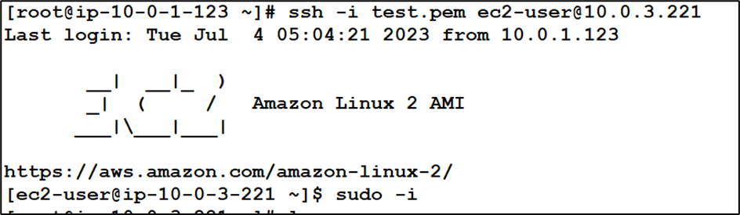

**[ec2-user@ip-10-0-03-221 ~]$ sudo -i**

**[ec2-user@ip-10-0-03-221 ~]$ vi test.pem**

**[ec2-user@ip-10-0-03-221 ~]$ chmod 400 test.pem**

**Natgateway: net connected in httpd server**

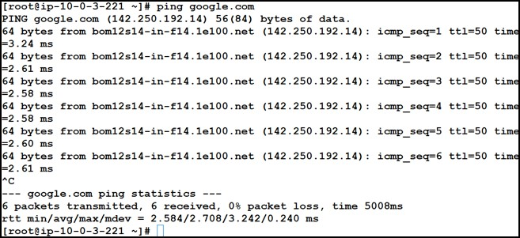

**With Natgateway: httpd also installed:**

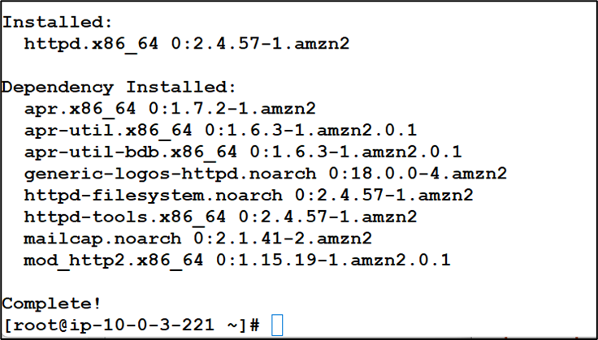

**Connected to sql server (3)from httpd server:**

[root@ip-10-0-3-221 ~]# ls

test.pem

[root@ip-10-0-3-221 ~]# ssh -i test.pem ec2-user@10.0.5.5

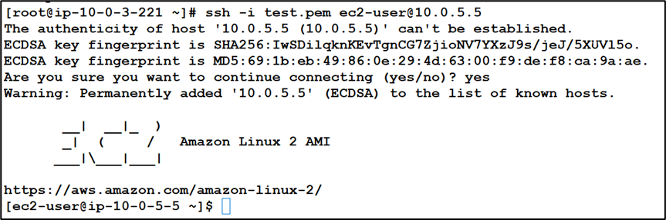

**With natgateway: Connected internet in the mysql server**

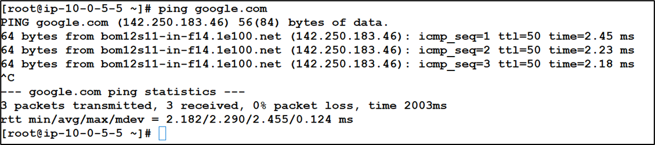

**With Natgateway: httpd also installed:**

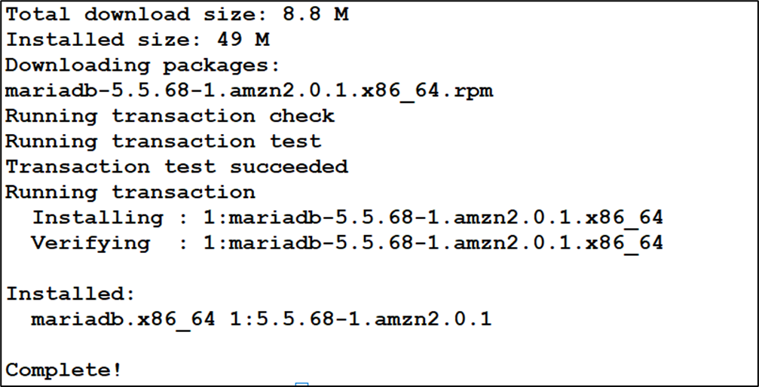

**7.How to enable VPC Flow logs & Export the logs to AWS S3?**

**VPC Flow Logs**

* Capture information about IP traffic going into your interfaces:

1. VPC Flow Logs
2. Subnet Flow Logs
3. Elastic Network Interface (ENI) Flow Logs

* Helps to monitor & troubleshoot connectivity issues
* Flow logs data can go to S3 / CloudWatch Logs
* Captures network information from AWS managed interfaces too: ELB, RDS, ElastiCache, Redshift, WorkSpaces, NATGW, Transit Gateway.

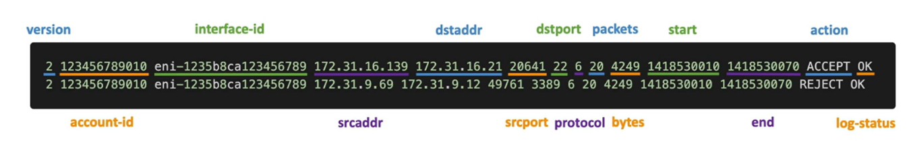

* **srcaddr & dstaddr** — help identify problematic IP
* **srcport & dstport** — help identity problematic ports
* **Action** — success or failure of the request due to Security Group / NACL
* Flow logs Can be used for analytics on usage patterns, or malicious behavior.
* **Query** VPC flow logs using Athena on S3 or CloudWatch Logs Insights
* **Flow Logs examples:** https://docs.aws.amazon.com/vpc/latest/userguide/flow-logs-records-examples.html

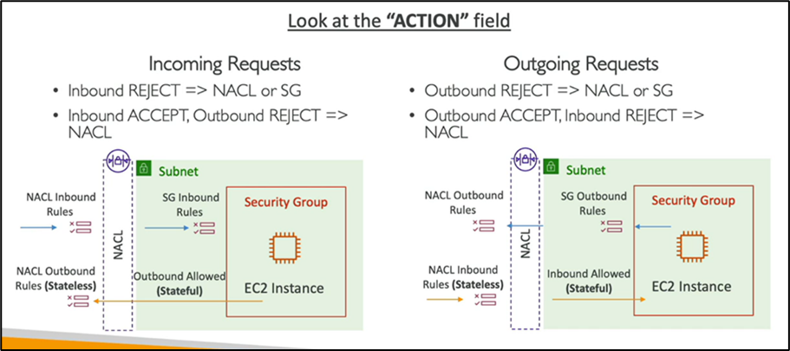

**VPC flow log architecture:**

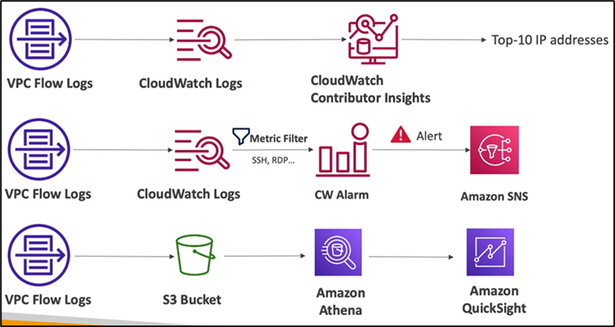

**Hands on -steps:**

**Step 1: VPC creation with 2 subnets, bastion server, private ec2, 2 RTs, 2 SGs, 1 IGW, 1 NAT GW**

**Step 2:**

**1.flow log creation with CloudWatch flowlogs**

**2. flow log creation with amozon S3 and anthena editor**

**1.VPC flow log creation with CloudWatch flowlogs**

1. Log group creation using cloud watch logs
2. Role creation with custom policy: “Service”: “vpc-flow-logs.amazonaws.com”, with **“cloudwatchrolefullaccess”** 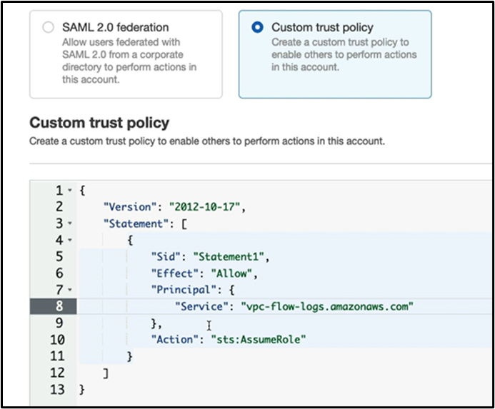
3. Now include above details in the VPC flow log creation step
4. After creating flowlogs : If we refresh VPC flow logs, entries got updated

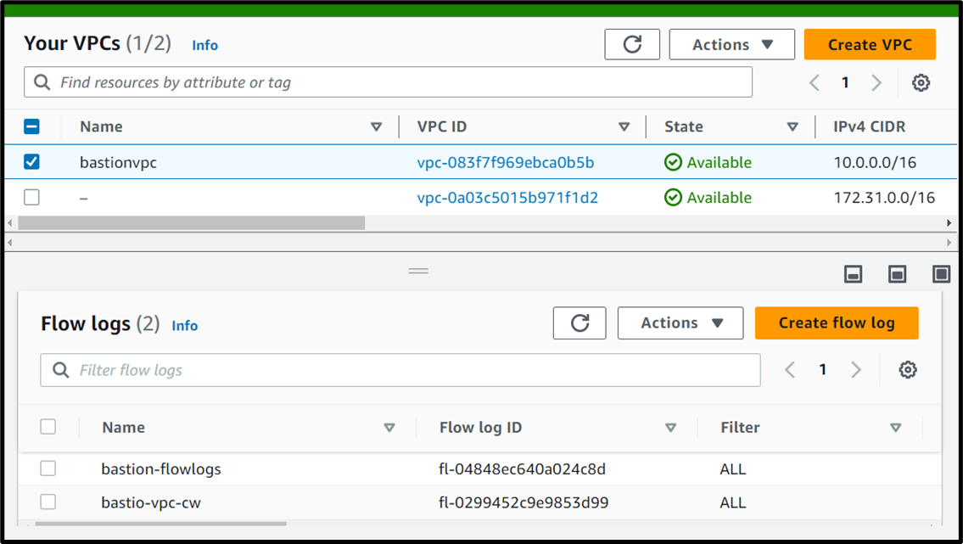

1. Go to flowlog groups in the cloud watch page. Refresh and fetch the details of log streams

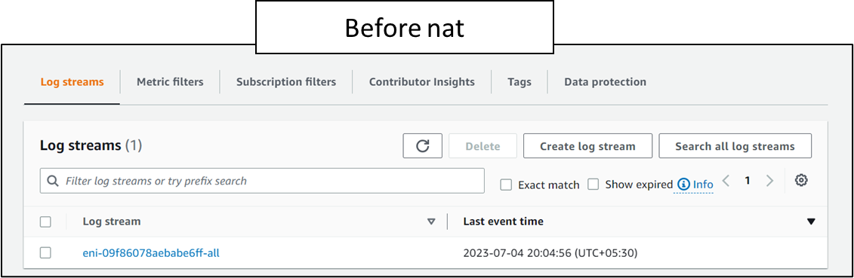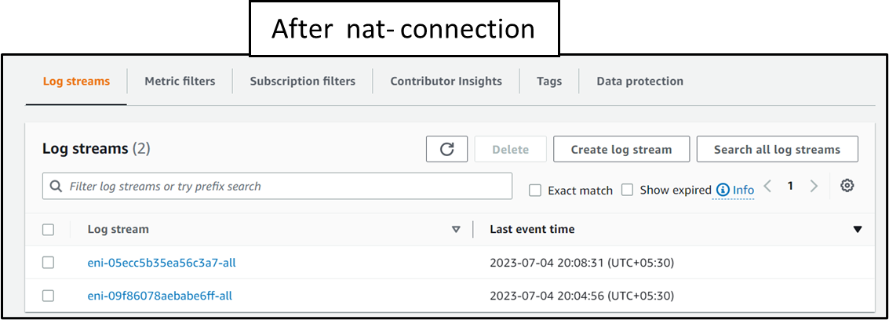

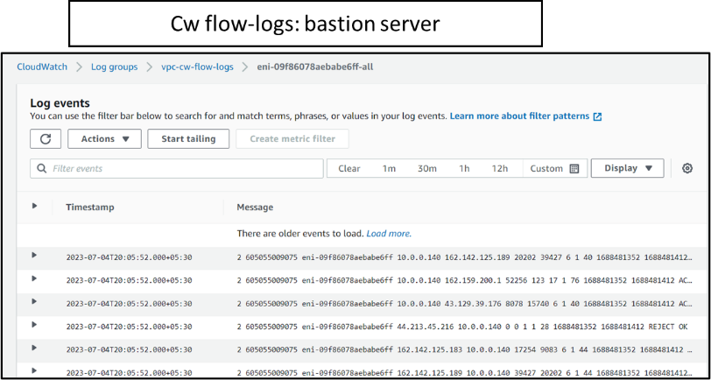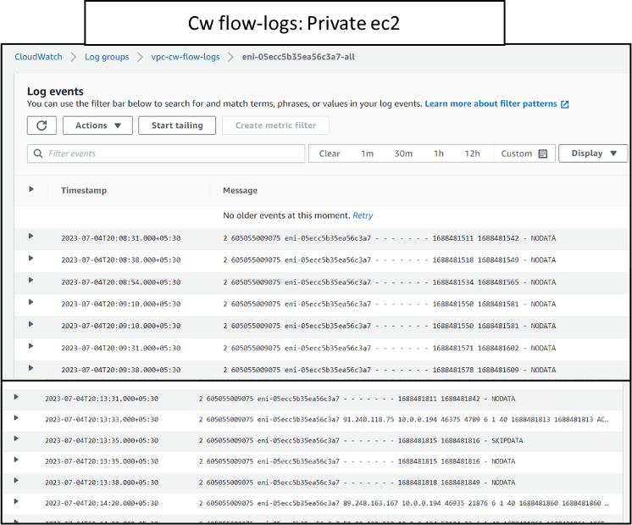

**2. Flow log creation with amozon S3 and anthena editor**

**Part 1:**

1. Flow log creation with s3 bucket creation (create a bucket and give the arn address in box)
2. Goto s3 bucket , refresh to get the uploaded logs.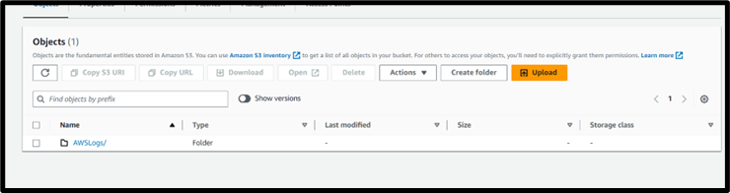

**Part 2:**

1. S3 bucket creation for anthena results storing location
2. Go to anthena and goto settings and mention above created bucket location

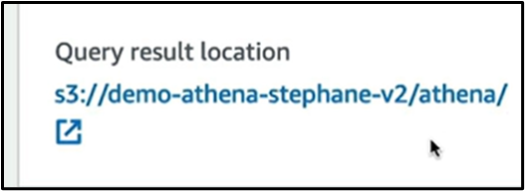

1. Save and goto editor where program statements for table creation is required to get results.
2. Goto this link: https://docs.aws.amazon.com/athena/latest/ug/vpc-flow-logs.html
3. Copy the first program statement, edit location, paste and run in the anthena editor --- flow logs will be created 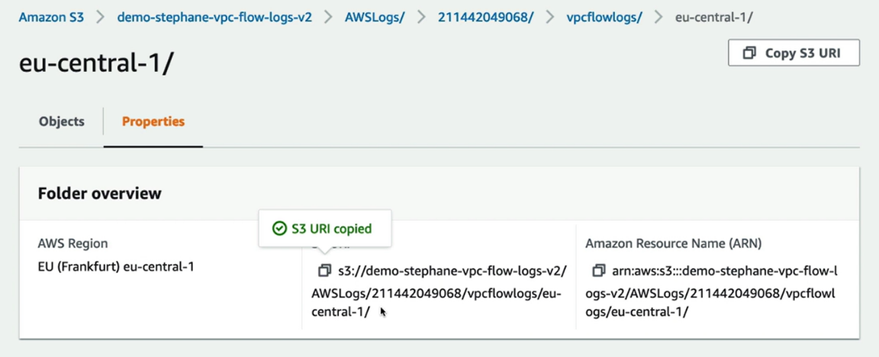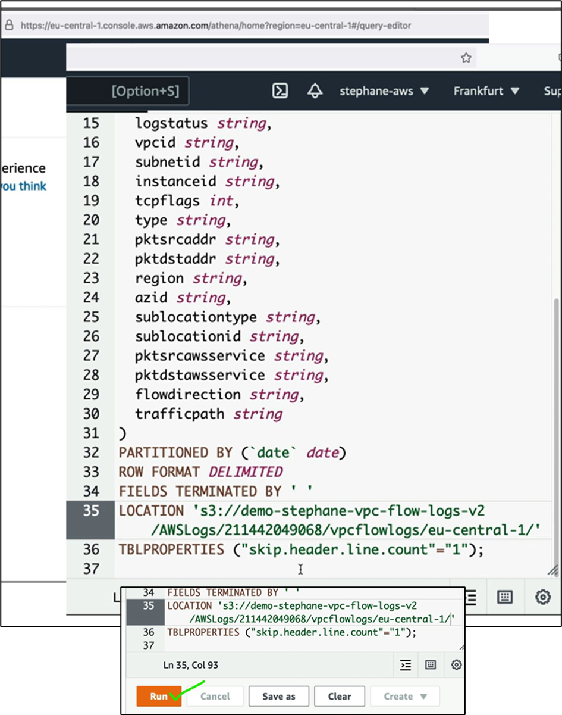

**Copying and modifying the s3 bucket location**

1. After editing the location, run the statement

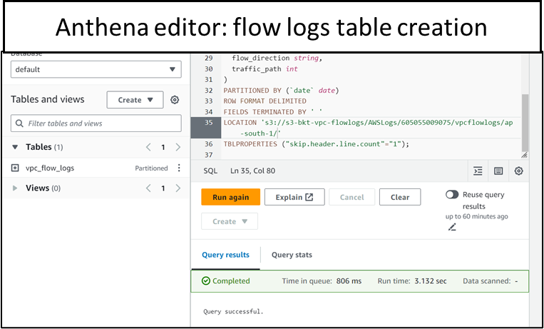

1. create a single partition using the below query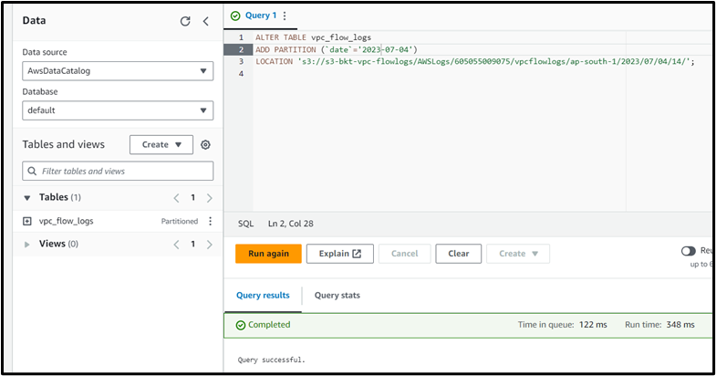
2. This query lists all of the all TCP connections

SELECT day_of_week(date) AS

day,

date,

interface_id,

srcaddr,

action,

protocol

FROM vpc_flow_logs

LIMIT 100

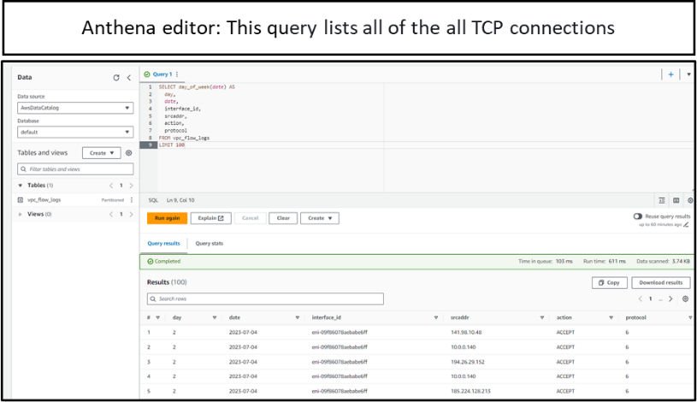

1. Query stats: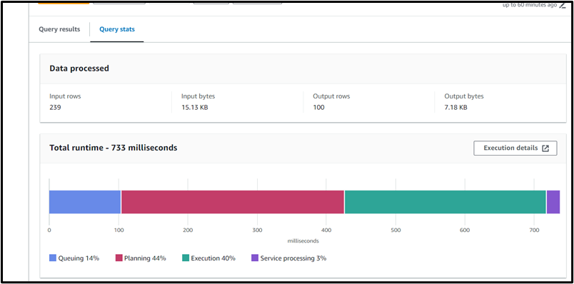
2. Csv files of logs: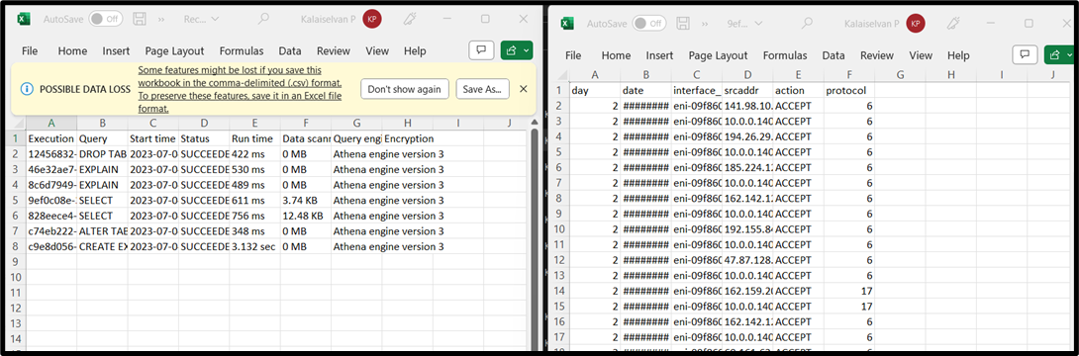
3. Recent queries

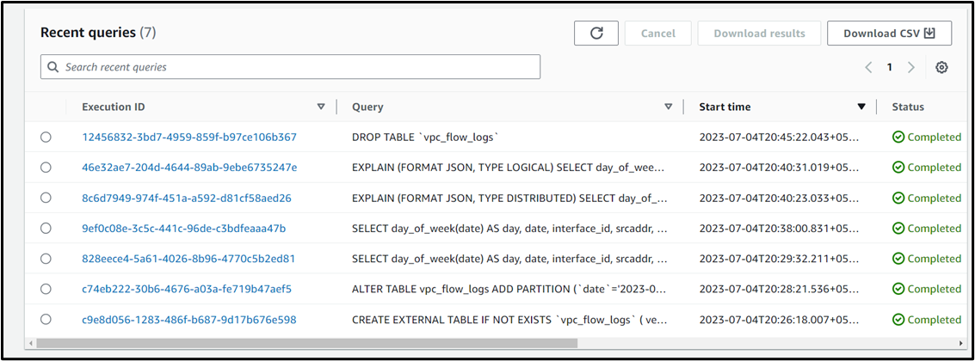

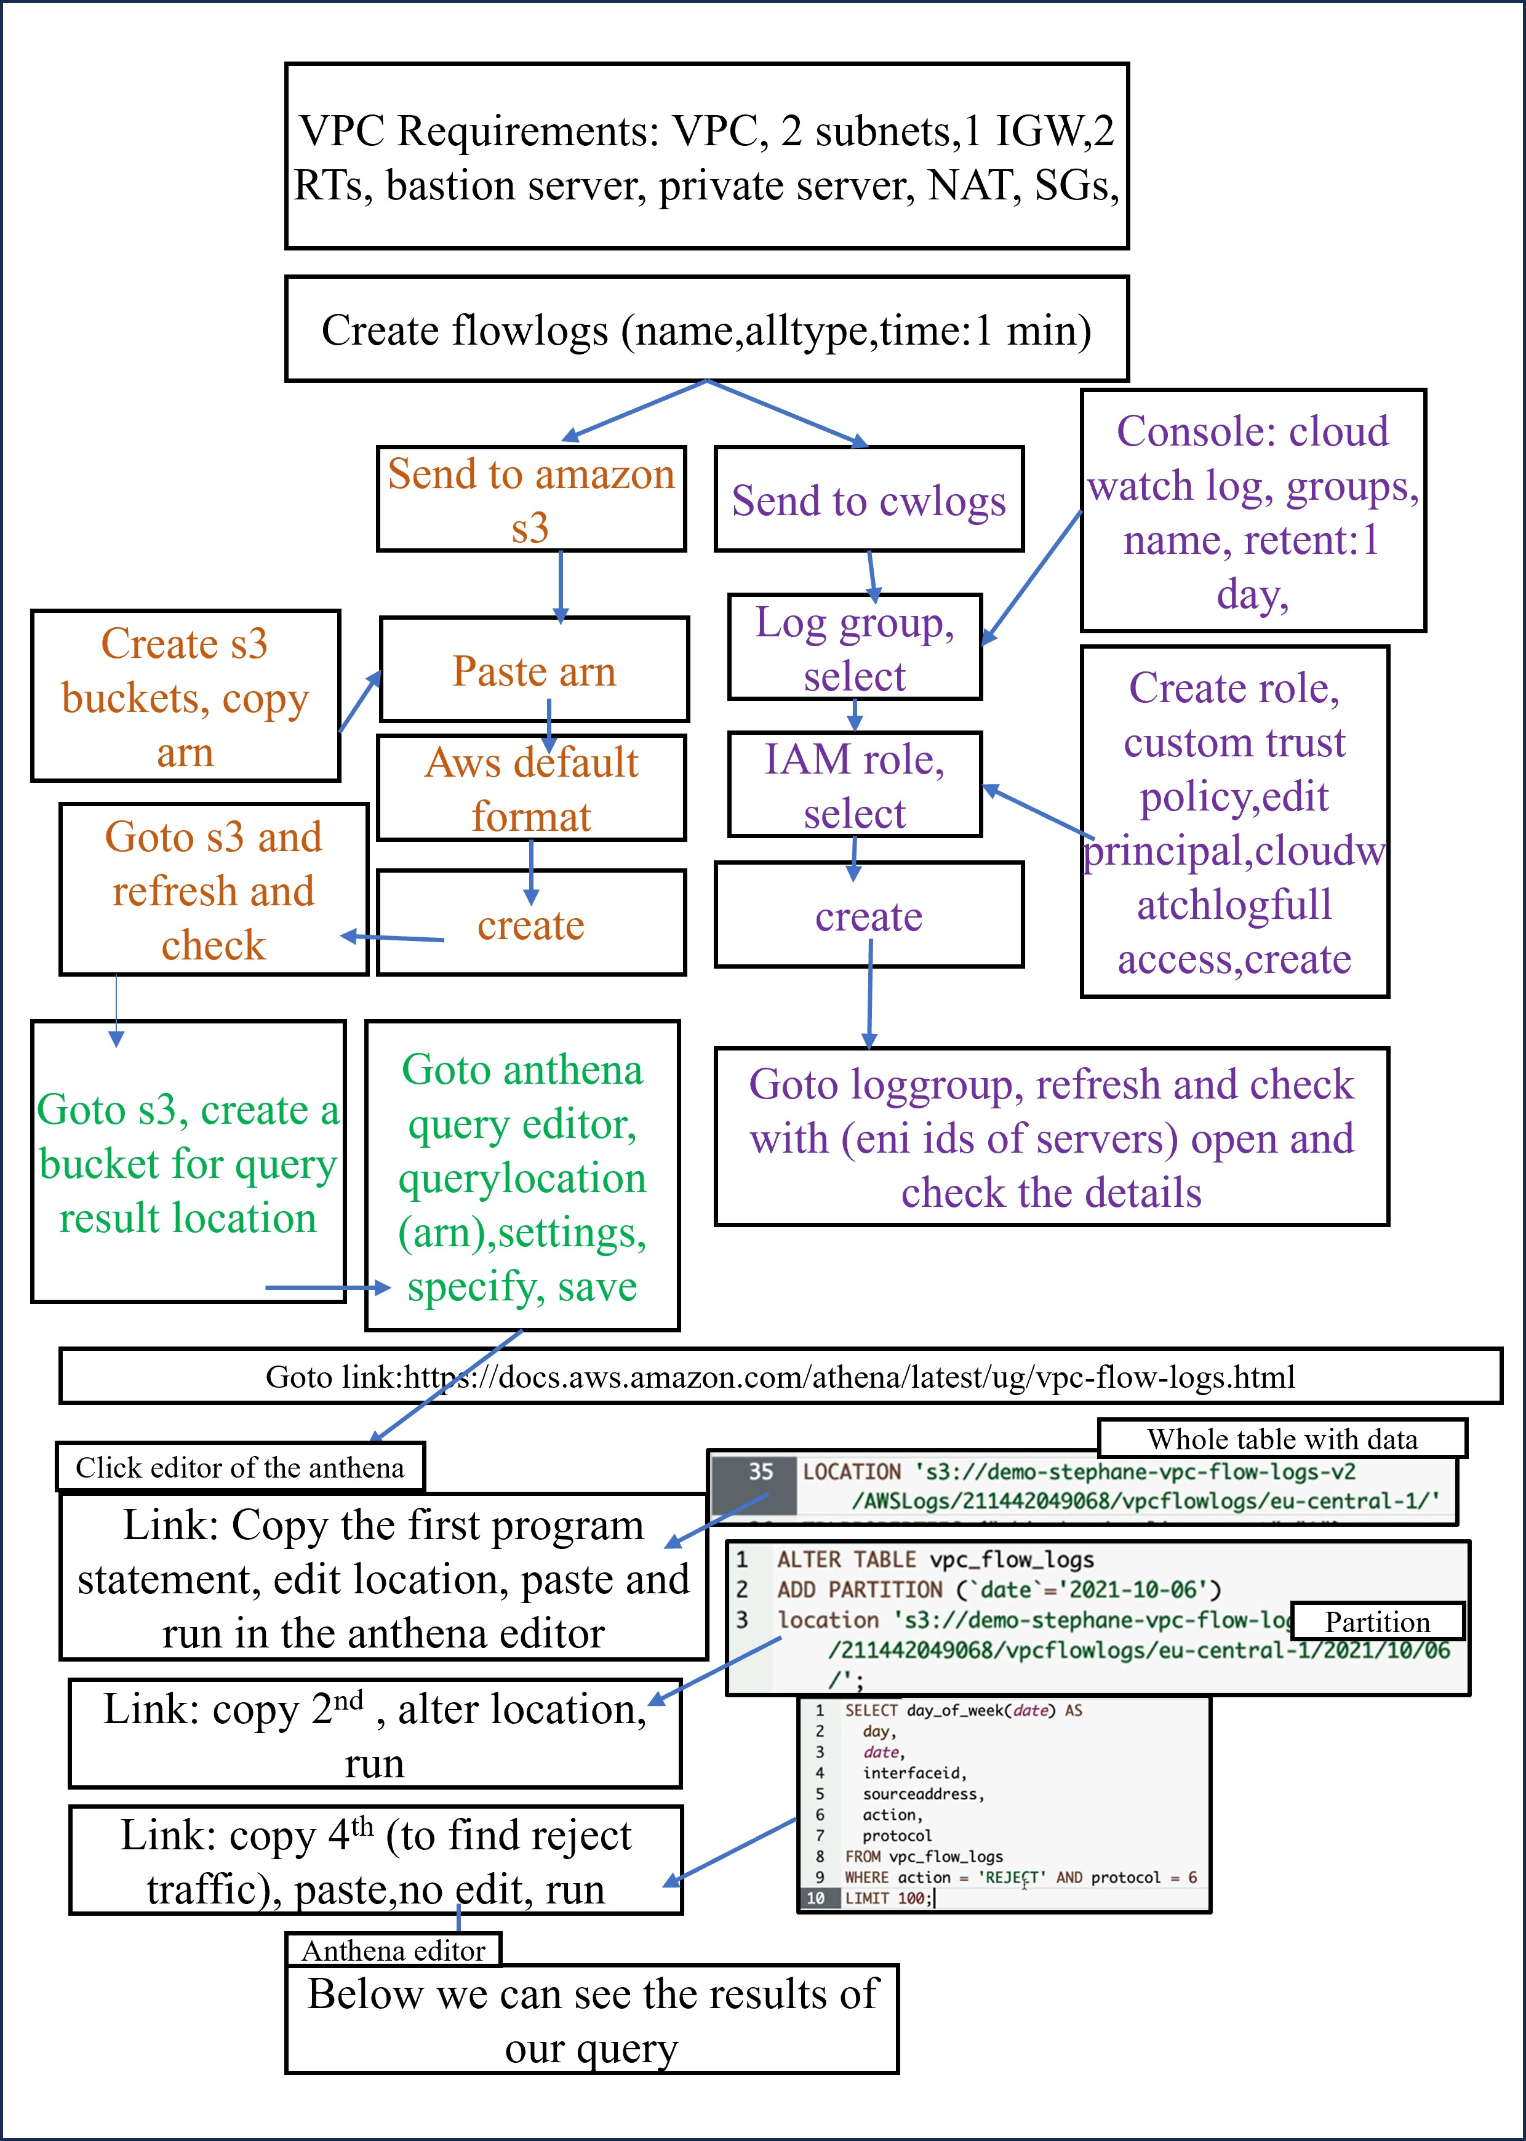

**8.Is it possible to edit VPC CIDR & Subnet CIDR?**

It’s not possible to change or modify the IP address range of an existing virtual private cloud (VPC) or subnet. However, we can do one of the following:

* Add an additional IPv4 CIDR block as a secondary CIDR to your VPC.
* Create a new VPC with your preferred CIDR block and then migrate the resources from your old VPC to the new VPC (if applicable)1.

**Note : cidr values and respective ip,s:**

https://www.freecodecamp.org/news/subnet-cheat-sheet-24-subnet-mask-30-26-27-29-and-other-ip-address-cidr-network-references